Experiment No. 2
Aim: Install Git and set up a new repository. Learn fundamental Git commands: add, commit, modify, and view. Create and manage branches for version control

Theory:
Git: Git is a free and open-source distributed version control system responsible for everything GitHub-related that happens locally on your computer.
Git Hub:
Operations on Git Hub:
Commit:
Push:
Modify:

Practical:
Step 1: Install visual studio.
Step 2: Install Github. Go to Github.com - - > log in with a Google account.
Step 3: Go to VS code - - > select extension option - - > Select github pull requests from search - - > Install it.
Step 4: Go to Sign in option at bottom right corner in VS code. - - > select github sync settings - - > Sign in or continue with github login. - - > Continue - - > Authorize VC code. - - > Click checkbox and select open.

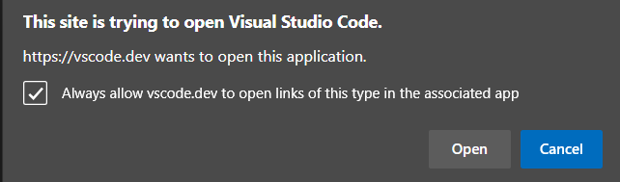

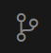
Step 5: create one folder as gitfolder1 on local drive. Go to File menu and open empty folder. Folder will appear in Explorer column. Click on source control option.

Click on "Initialise Repository." It indicates that the folder is empty and can be used to store files.
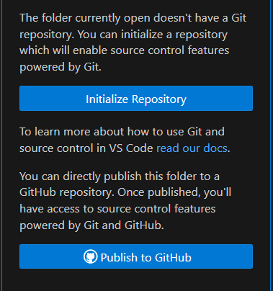
OR
This can be done with a command in the terminal as git init.
Step 6: Click on + sign to add contents to local folder. This will store the file in local folder gitfolder1.
OR
Use git add . command on terminal.
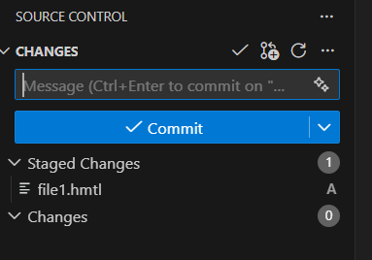

Step 7: Type message – “My First Commit” and click on correct sign.
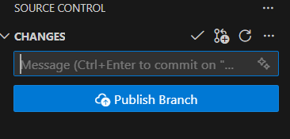
Or
For terminal run command as – git commit -a -m “This is my first commit”

Step 8: Add remote to connect local repository to github repository. Click on three dots in explorer to open pull down menu for operations.
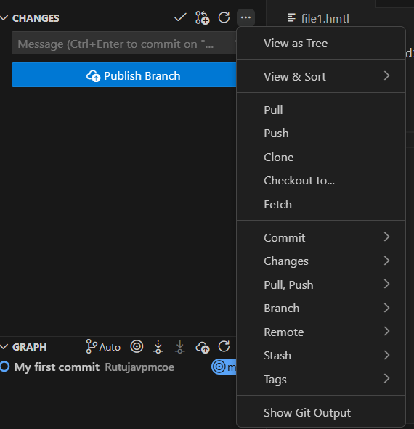
Select Remote- Click on add remote. Go to Github and copy repository URL and paste it in add Remote from Github.
Give name to remote as ‘Origin’
Select push to operation form pop up of three dots
OR
Run command as – git push origin main
This will save file in repository exp2. Go to github and refresh the page to see files in the repository.

Step 3: Set up a new repository
- Click on New to create a new repository

- A new window will open
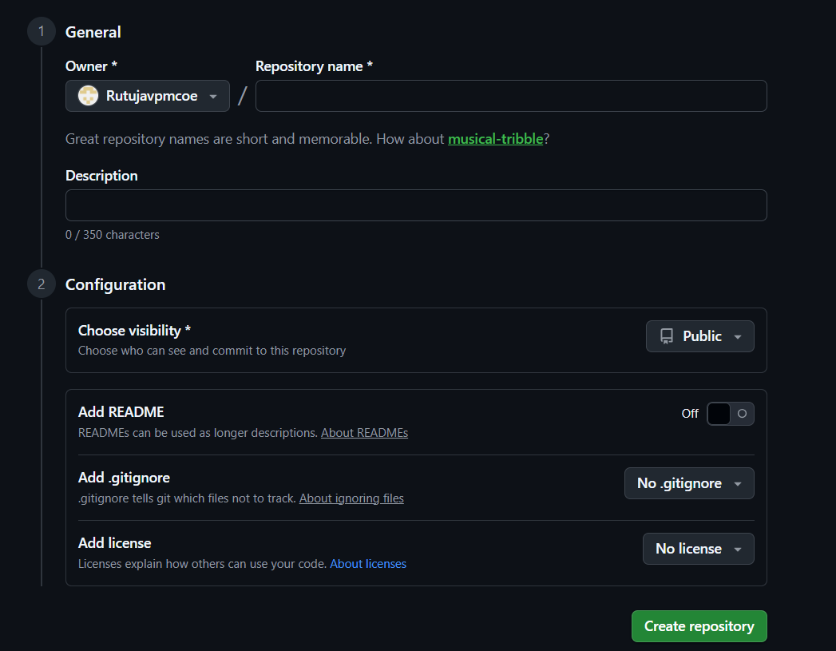
Give a name to the new repository. Describe the repository's contents. Without changing remaining settings, click on Create repository. Example: my repository is Web_Tech_Exp2
Step 3: Install git. Go to Google - - > Search for git cli - - > Downloads git - - > Download git tool as per your operating system. Open the downloaded exe file. Click on next to complete the installation
To verify the installation, open the Command Prompt (Terminal). Type git command.
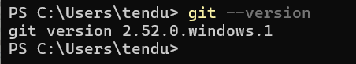
Step 4: Create a notepad file and store it in a folder. Go to terminal - - > change directory with your folder name
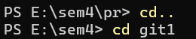
Step 5: Initialize git.
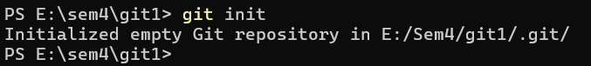
Type the following commands:
PS E:\sem4\git1> git config --global user.name "Rutujavpmcoe" // Give your username
PS E:\sem4\git1> git config --global user.email “rgtendulka@vpmthane.org // Give your email id same as the one used to sign in github
Check git status by giving the following command:
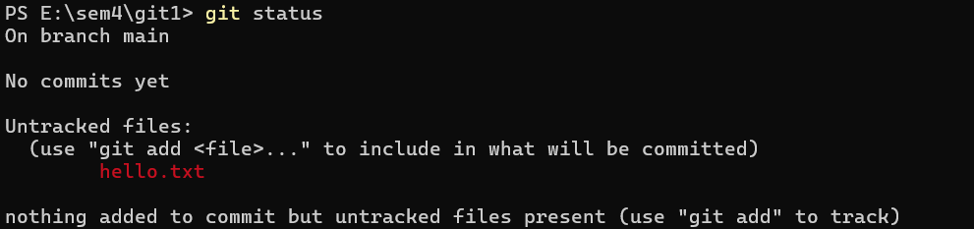
Step 6: Add file for tracking
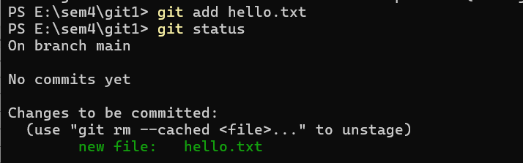
Step 7: commit operation for tracking and staging.
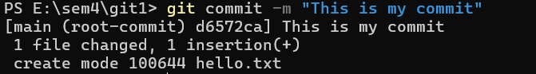
Step 8: connect to the main repository. Add the repository path from git site as shown in the following window.
PS E:\sem4\git1> git remote add origin https://github.com/Rutujavpmcoe/Web_Tech_Exp2.git
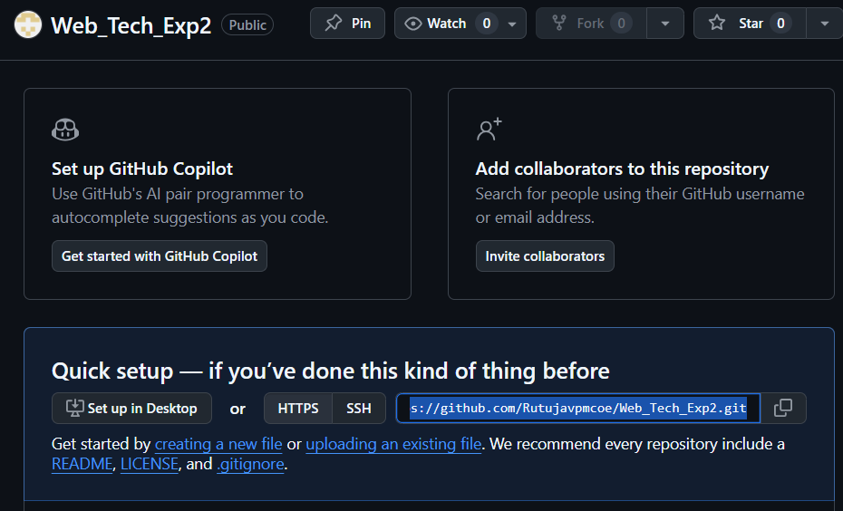
Step 9: Push code to the repository
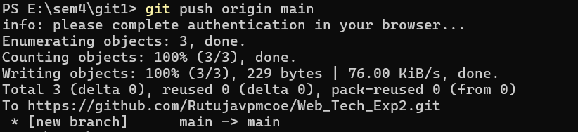
Refresh the GitHub web page. It will display the hello.txt file in the repository Web_Tech_Exp2.
Step 10: Open the notepad file on your device. Make some changes in it. Save file.
Perform the following operation to save changes in git.
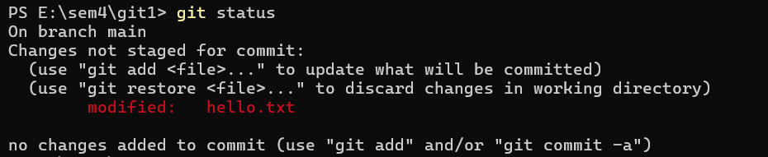
If you don’t want to save the changes then give command as : git restore hello.txt
Changes made to the files are not stored. They are discarded.
Again, make changes to the file and save it. Go to the terminal and check git status. It shows two files in the repository.
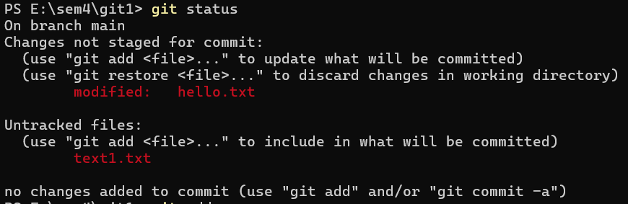
To keep both files in git type following command: To make all changes use add . (dot).
Check git status:
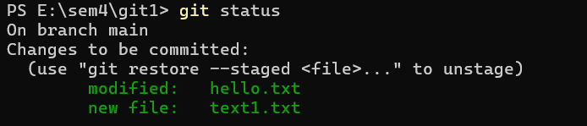
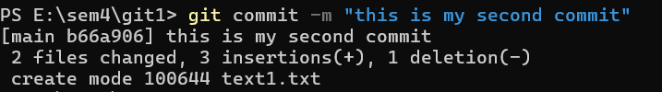
To push second file in git:
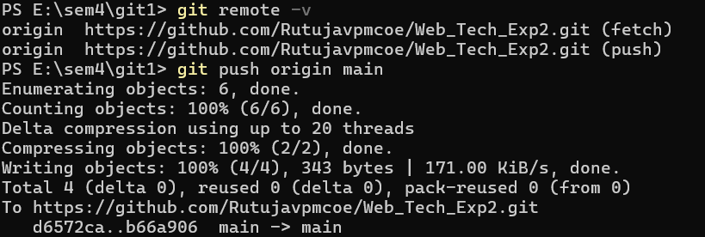
Step 11: To clone the repository: Create a new folder on the PC, such as gitclonefolder. Go to the terminal and change the directory to the new folder.
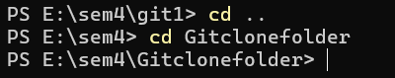
To clone a folder, copy the path of the existing folder from git web page.
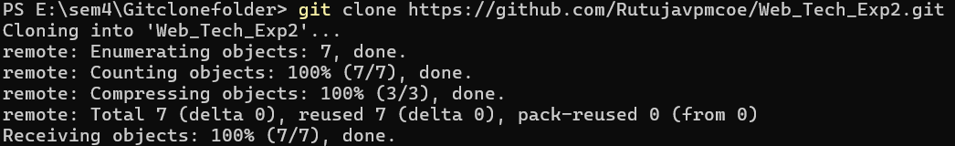
Change the path to repository name cloned in the new folder. Create a new document as new. Check git status. It will show you a new file in the folder.
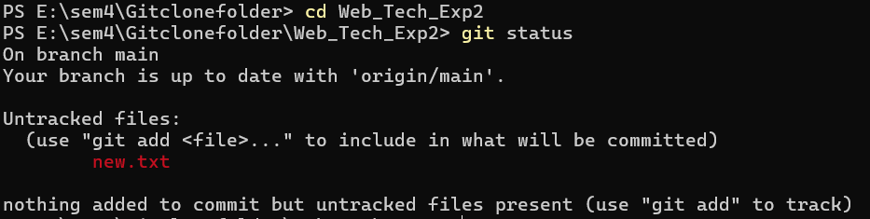
Committing in cloned repository:
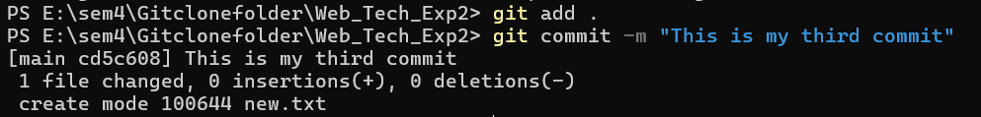
Push files on git:
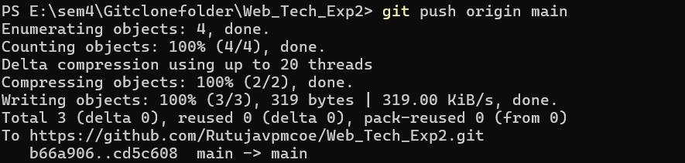
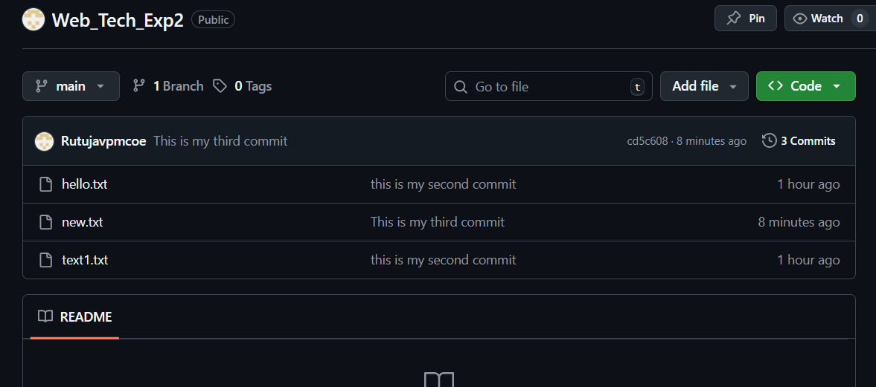
Conclusion: Successfully Installed Git and perform commit,push operations on Git for tracking files in staging environment.

